Mastercard theforage.com Phishing Detection and Prevention Job Simulation

Objectives:

* Identify phishing email,
* help identify and report security threats such as phishing
* Analyzed and identified which areas of the business needed more robust security training
* implemented training courses and procedures

Skills:Communication, Cybersecurity Data analysis, data presentation, thinking and problem solving, security awareness trainings, strategic training, security awareness

What is phishing?

* Phishing is when an attacker sends a fake email with the intent to get information
* Attackers will attach links or attachments that when clicked on will install malicious software on your system
* Successful phishing attempts can cost companies like Mastercard millions of dollars and put our employees at risk. So it’s very important that we keep the business and our staff safe from harm.

Task 1:Design a phishing simulation campaign used by Mastercard

Example Phishing Email: What are the indicators that this is a phishing email?

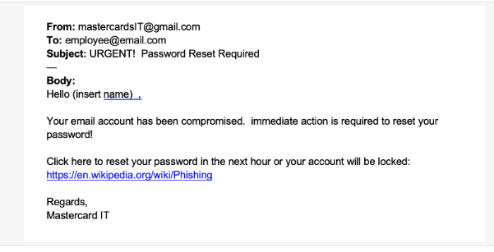

* The source email is spelled wrong. This simulation is for mastercard not mastercards and is from a gmail account instead of a mastercard email account.
* The sender used a generic greeting, the message is vague and does not provide enough information.
* Urgency tactic
* Hyperlink is not from the same website

Task 2: Recreate the previous email and make it look more believable?

Inserting the name of the recipient

From: mastercard@gmail.com

To: Annsmith@gmail.com

Subject: Mastercard Data Breach Password Reset Required

Hello Ann,

Our team here at Mastercard has been notified of a data breach of many of our users passwords.You are a valued customer and we want to ensure your protection and security To ensure your account is not compromised please reset your password below.

Click here to reset your password: for security purposes the link is only valid for the next 24 hours. If the time expires reply to this email to request a new one https://mastercard.us/resetpasswd

Regards,

Mastercard IT

Task 3: This is the percentages of each team at Mastercard and how they do when it comes to phishing. Identify the most at risk teams, create a presentation to educate the team. 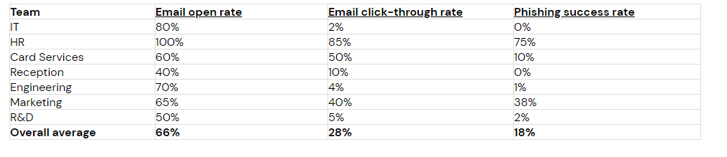

Create a phishing educational presentation:

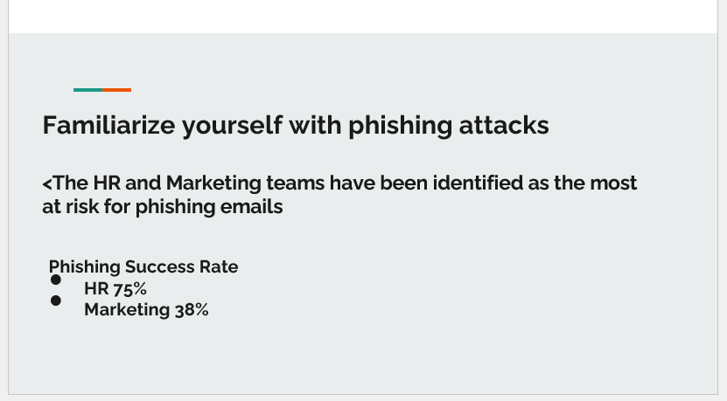

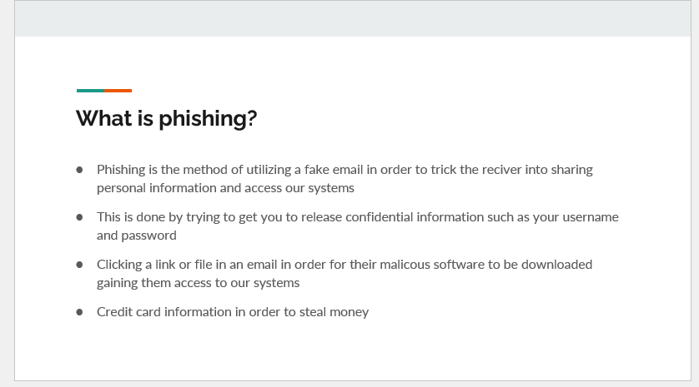

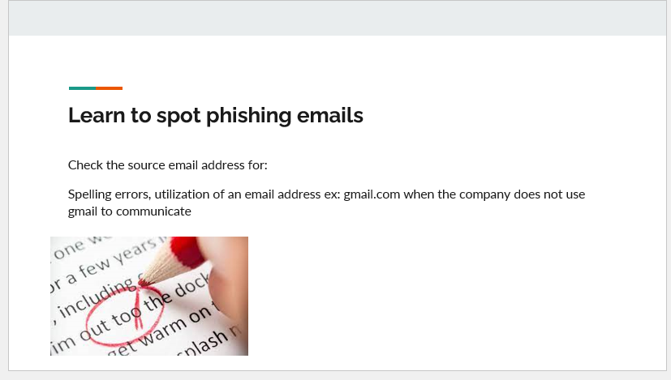

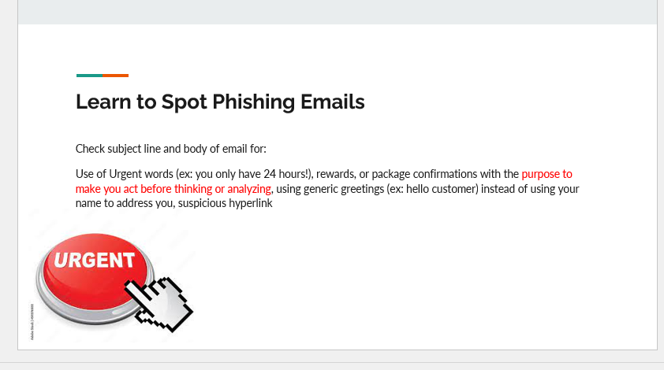

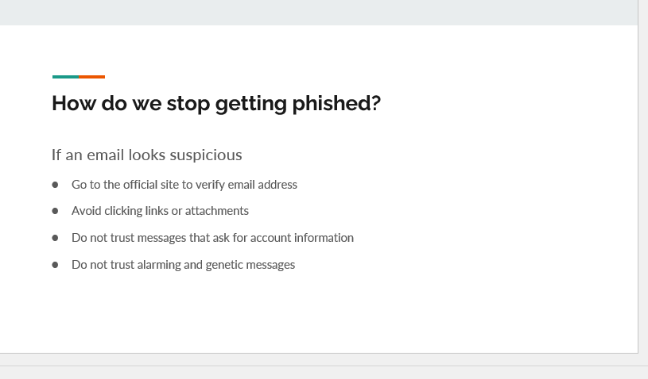

Link to powerpoint [Phishing .pptx](https://1drv.ms/p/s!ApHt4IwcovPEix7yKhkXmQlqBGiM?e=IncjgX)